1)<script>

let me="Hello World";

alert(me);

</script>



2) <script>

const num=2;

let str="Vish";

let BigInt=1223456789n;

let u;

console.log(num);

console.log(str);

console.log(BigInt);

console.log(typeof num);

console.log(typeof str);

console.log(typeof BigInt);

console.log(typeof u);

</script>

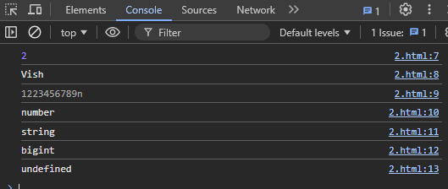

4) <script>

var first="Vishnu";

var second="Priya";

document.write(first+second);

<script>



3) <script>

var a=20;

var b=100;

console.log(a+b);

console.log(b-a);

console.log(b/a);

console.log(a*b);

</script>



5) <script>

var b;

const c=null;

let name = {

age: 30,

};

let rno = Symbol("rollno");

name[rno] = 62;

let num = 1300;

document.write("Type of rno: " + typeof rno + "<br>");

document.write("Type of name: " + typeof name + "<br>");

document.write("Type of num: " + typeof num + "<br>");

document.write("Type of b: " + typeof b + "<br>");

document.write("Type of c: " + typeof c + "<br>");

</script>

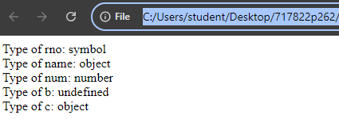

6) <script>

//This is the example of single line comment.

document.write("Hello");

/*hello heloooo

This is multiline

comment's example*/

</script>

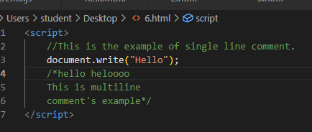

7) **With semi colon: Without semi colon:**

<script **>**

document.write("Hello"+"<br>");

document.write("I am a college student"+"<br>");

document.write("in this college"+"<br>");

</script>

<script **>**

document.write("Hello"+"<br>");

document.write("I am a college student"+"<br>");

document.write("in this college"+"<br>");

</script>

   
No difference in the output!!!

9)

<script>

let a,b,c,d;

a=10;b=20;c=30;d=40;

document.write(a+b+c+d);

</script>



8)

<script>

let rows = 5;

let columns = 5;

for (let i = 1; i <= rows; i++) {

for (let j = 1; j <= columns; j++) {

document.write((i * j) + "\t");

}

document.write("<br>");

}

</script>

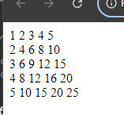

10) Scripts can modify HTML elements, so placing the <script> tag at the bottom of the <body> ensures that HTML elements have fully loaded, reducing the risk of modifying elements causing errors